NAME:K.Subashree
REGNO:192521396
EXPERIMENTS 11 TO 21
EXPERIMENT 11
CODE
data <- read.csv("students_copy.csv", header = TRUE)
cat("Contents of the CSV file:\n")
print(data)
OUTPUT
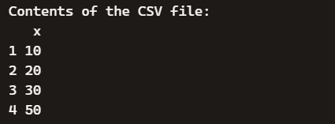
EXPERIMENT 12
CODE
data("airquality")
result <- aggregate(cbind(Ozone, Solar.R, Wind, Temp) ~ Month,
data = airquality,
FUN = mean,
na.rm = TRUE)
cat("Monthly average values:\n")
print(result)
OUTPUT
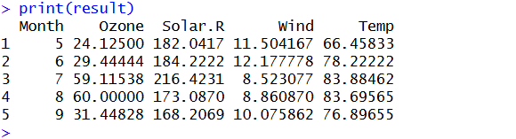
EXPERIMENT 13
CODE
rm(list = ls())
a <- c(1, 2, 3)
b <- c(4, 5, 6)
c <- c(7, 8, 9)

d <- rbind(a, b, c)

cat("Combined arrays (row-wise):\n")
print(d)
OUTPUT
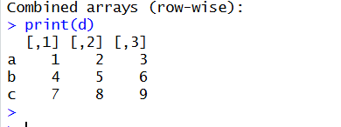
EXPERIMENT 14
CODE
data("ChickWeight")
head(ChickWeight)

sorted <- ChickWeight[order(ChickWeight$weight), ]
cat("Sorted data by weight:\n")
print(sorted)

cat("Average weight by Diet:\n")
print(aggregate(weight ~ Diet, data = ChickWeight, FUN = mean))
OUTPUT
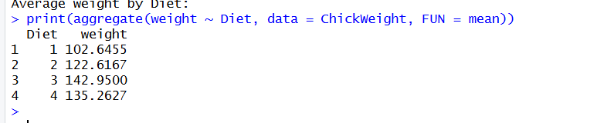
EXPERIMENT 15
CODE
data("iris")
dim(iris)
summary(iris)
sapply(iris[,1:4], sd)
quantile(iris$Sepal.Length)
aggregate(. ~ Species, data = iris, FUN = mean)
OUTPUT
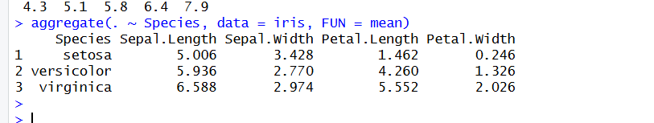
EXPERIMENT 16
CODE
data("USArrests")
summary(USArrests)
which.max(USArrests$Rape)
max(USArrests$Murder)
min(USArrests$Murder)
cor(USArrests)
hist(USArrests$Murder,
col = "lightblue",
main = "Histogram of Murder Arrests",
xlab = "Murder Arrests")

OUTPUT
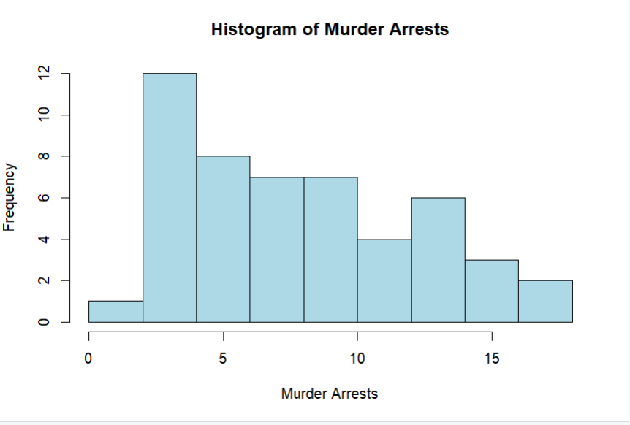
EXPERIMENT 17
CODE
data("Titanic")
t <- as.data.frame(Titanic)

barplot(table(t$Class, t$Survived),
main = "Survival vs Class",
beside = TRUE,
col = c("skyblue", "orange", "lightgreen", "pink"),
legend = rownames(table(t$Class, t$Survived)))

barplot(table(t$Sex, t$Survived),
main = "Survival vs Gender",
beside = TRUE,
col = c("lightblue", "lightcoral"),
legend = rownames(table(t$Sex, t$Survived)))

OUTPUT
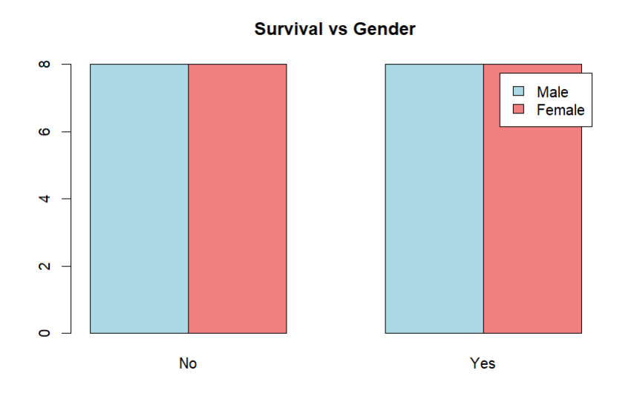
EXPERIMENT 18
CODE
x <- c(10, 20, 30, 40, 50)
y <- c(5, 15, 25, 35, 45)

par(mfrow = c(2, 3))

boxplot(x, main = "Boxplot", col = "lightblue")
hist(x, main = "Histogram", col = "lightgreen")
barplot(x, main = "Bar Plot", col = "orange",
names.arg = c("A", "B", "C", "D", "E"))
plot(x, type = "l", main = "Line Chart", col = "blue")
plot(x, y, main = "Scatter Plot", col = "red")

OUTPUT
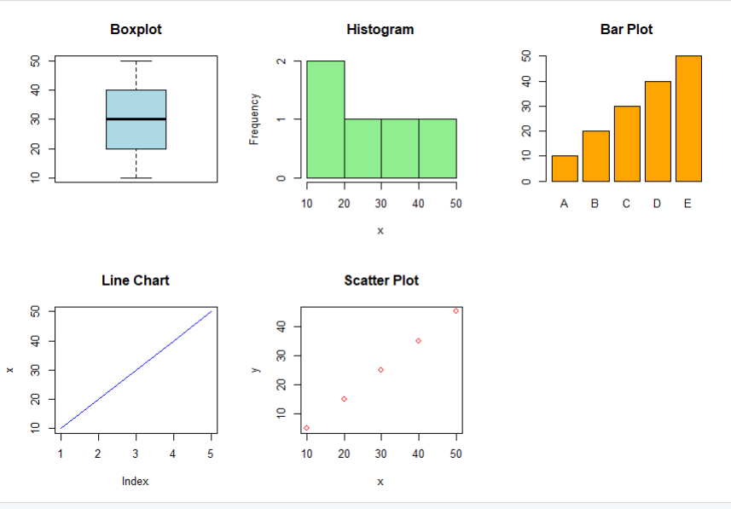
EXPERIMENT 19
CODE
Spend <- c(10, 20, 30, 40, 50)
Sales <- c(15, 25, 35, 45, 55)

model <- lm(Sales ~ Spend)
predict(model, data.frame(Spend = 60))
OUTPUT
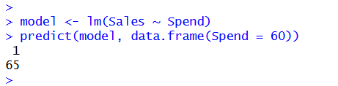
EXPERIMENT 20
CODE
data("ChickWeight")
m <- lm(weight ~ Time + Diet, data = ChickWeight)
p <- predict(m)
mean((ChickWeight$weight - p)^2)
OUTPUT
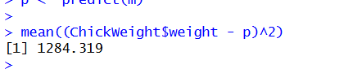
EXPERIMENT 21
CODE
data("iris")
iris <- subset(iris, Species %in% c("setosa", "versicolor"))
m <- glm(Species ~ Petal.Length + Petal.Width,
data = iris,
family = binomial)
p <- ifelse(predict(m, type = "response") > 0.5,
"versicolor", "setosa"
table(p, iris$Species)
OUTPUT
